***F****ind* ***O****ur* ***R****oom****M****ate* ***Q****uestionnaire*

***A project from FROM Q***

***29 January 2018***

*Group Members:*

*Samad Farooqui*

*Andrea O’Brisky*

*Omer Osman*

*Osama Minhas*

*Haochang (Caspar) Qian*

*A project for Web Science Systems Development, Spring 2018*

***Summary of the proposed project and team structure:***

Team FROM Q is a team built of five Information Technology and Web Science (ITWS) students at Rensselaer Polytechnic Institute (RPI).

Samad Farooqui is a junior Computer Science (CS) and ITWS dual major. He has experience as a Software Development Intern at Optum, and currently serves as a Resident Assistant at RPI. His skills include Python, basic Natural Language Processing, HTML5, CSS, JavaScript, Bootstrap, jQuery, PHP, and C/C++. He will serve as a Front End Developer for this project.

Osama Minhas is a sophomore CS and ITWS dual major. His skills include PHP, SQL, HTML5, CSS, JavaScript, jQuery, C/C++, and Python. He will serve as a Full Stack Developer for this project.

Andrea O’Brisky is a junior ITWS major with a concentration in Biotech. She has experience working as an IT research & development at Johnson and Johnson, a Research Assistant at Biomedical Imaging Center, Learning Assistant at RPI and Website Manager for the Women's Mentoring Program. Her skills include Front End Development, Python, HTML5, CSS, JavaScript, Bootstrap, and jQuery. She will serve as a Front End Developer for this project.

Omer Osman is a senior ITWS major with a concentration in Management Information Systems. He has experience as an IT Project Management Intern for the New York State Workers’ Compensation Board, a System Administrator for Annur Islamic School, and as Webmaster for RPI’s Muslim Student Association. His skills include SQL, PHP, HTML5, CSS, JavaScript, Bootstrap, jQuery, C/C++, and Python. He will serve as a Back End Developer for this project.

Haochang Qian is a sophomore CS and ITWS dual major. He has experience in Full Stack Development, and Laravel Framework Applications. His skills include Back End Development, PHP, HTML5, CSS, JavaScript, Bootstrap, jQuery, C/C++, Java, PS/ID/AI, and Python. He will serve as a Back End Developer for this project.

The team proposes a replacement to the StarRez system currently used by RPI’s office of Student Living and Learning (SLL) in order to match students to roommates and housing on campus, called Find Our RoomMate Questionnare, or FORM Q. The team believes that their matching service can be greatly improved using the proper algorithms, questions, profile setup, and many other key factors. StarRez only works for those planning to live on campus, and the team is also looking to help off-campus students match up with roommates. The team’s solution includes personal preferences, contact information, group profiles, and many more convenient features to help match students to their future roommates. Students will be able to form groups and include their traits, and other students will be able to search for roommates based on those traits. The project is primarily going to be designed as a website, but will be functional on most mobile browsers since the Frontend is being developed with Boostrap. Data is going to be stored in a relational database and will be secure; information such as contact information will be available to users of the site, but users will have the ability to put whatever they would like in those fields and can take down their information at will. The team is excited to put their skills to the test in developing this project.

***Description of each type of user and stakeholder, and how the site generates value for each:***

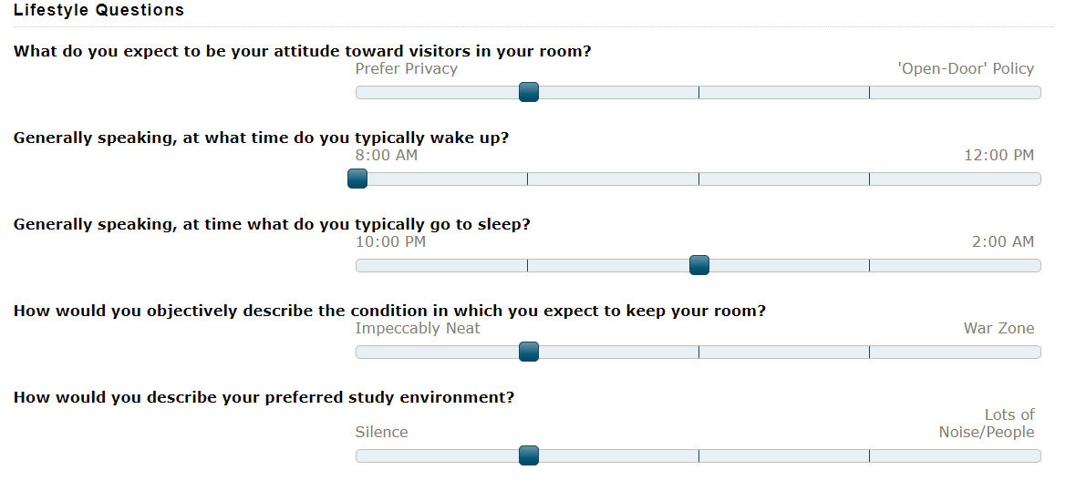

*Figure 1. Residence Life’s Roommate Matching Survey*

FORM Q is generally targeted at RPI students. At Rensselaer, many students have a difficult time finding roommates. There are resources targeted at helping students find roommates; for example, RPI’s SLL has a survey meant to match students with individual matches with similar characteristics. This may be a good start but it is flawed, with limited questions and options. There are two more important issues with the “solution” made by SLL that the team will fix. The first is that this website does not offer group matching, and the second is that this website is only an option for students looking to live on campus. As such, a large portion of upperclassmen students cannot use the website. Since the team is including features for students who live off campus and students searching for a group, the number of potential users increases greatly.

The website’s type of users include those looking to “advertise” for a roommate through the creation of a profile and those looking to search through profiles for roommates. Users can belong to both groups, meaning they can “advertise” for a roommate and search through other profiles. For users looking to “advertise” for a roommate, they will fill out a profile with contact information, preferences and be given the option to prioritize these preferences. For example, a user would be able to mark down that they prioritize limited noise when filling out their profile. If they are in a group, this profile will be a group profile. On group profiles, the group answers these preferences as one unit collectively.

Users looking to search for matches can search by number of people. For example, a group of two students may be looking to match with another two students in order to live in an apartment style complex for four people. They can specifically search for groups of two and see the collective profile of the other groups of two. This provides much more options for students, especially for those looking for apartments with large groups of people to join. From there, the student or group of students can reach out to potential roommates via the contact information provided on the profiles.

***A summary of the technologies the team intends to use:***

* Programming Languages
  + HTML/CSS - Used for site layout and design.
  + PHP/SQL - Used to store data about students' information, group details, etc.
  + JavaScript - Used for anything like slider to choose a preference. In other words, any special interactions with the page like hiding/showing certain information with clicks.
  + Bootstrap - Used to create cross-platform user friendly interface.
* Structure
  + MVC structure that separates data, backend logic, and frontend user interface.
* Frameworks
  + Angular - Quickly start building components, create UI views with simple and powerful template syntax. Simplify the process of designing complicated interactions in the view/webpage.

***Any functional and non-functional requirements:***

Functional Requirements:

These are the requirements of the website in order to ensure the project meets its goals.

* Process for normal users:
  + Users will be able to create accounts and log into them securely.
  + Users will be able to create groups.
  + Users will be able to specify traits & characteristics of their groups.
  + Users will be able to update groups.
  + Users will be able to search for people with similar characteristics.
  + Users will be able to view characteristics of other groups.
  + Users will be able to delete groups.
  + Users will be able to report other users.
  + Users will navigate simple, easy-to-use interfaces to accomplish tasks.
* Process for administrative users:
  + Admins will be able to blacklist reported users.
  + Admins will be able to delete groups.
  + Admins will be able to perform admin functions with an easy-to-use admin interface.
* People:
  + RPI students will be able to create accounts in order to become users.
  + The team will document any changes of scope in the website.
  + The team will document all aspects of the website in order to make development easier in the future.
* Database:
  + The Database will be a MySQL database.
  + The Database will store Users, Groups, and Admins relations.

Non-Functional Requirements:

These are the requirements to implement the system design specified above. They will help ensure the project comes to completion.

* Hardware
  + The team will develop locally on their machines.
* Software
  + The team will be creating the website and core functionality from scratch with the help of libraries like Bootstrap and jQuery.
  + The team will use a git repository for development.
  + The team will use a MySQL Database hosted on local machines for testing.
  + The website will be using valid code.
  + The website will be compatible with mainstream browsers including Google Chrome, Mozilla Firefox, and Microsoft Edge.
* Scalability
  + The project will be designed with scalability in mind for future improvements.
  + The project’s working versions will be available on GitHub.
* Security
  + The website will use RPI’s CAS system for login systems.
  + Users will be able to report other users who abuse the use of contact information.
  + Admin users will be the only ones with access to the administrative functions.
  + The website will be able to prevent SQL injection and other forms of injection attacks.
* Usage:
  + The codebase will be well documented in order to make future development seamless.
* Aesthetics:
  + The website will offer the look and feel of a website made for the modern age.

***An estimated project schedule:***

The team will be utilizing a mix of the agile development methodology and waterfall methodology in order to stay on track. Sprints will be on average two weeks long. Here is an estimated schedule of the project:

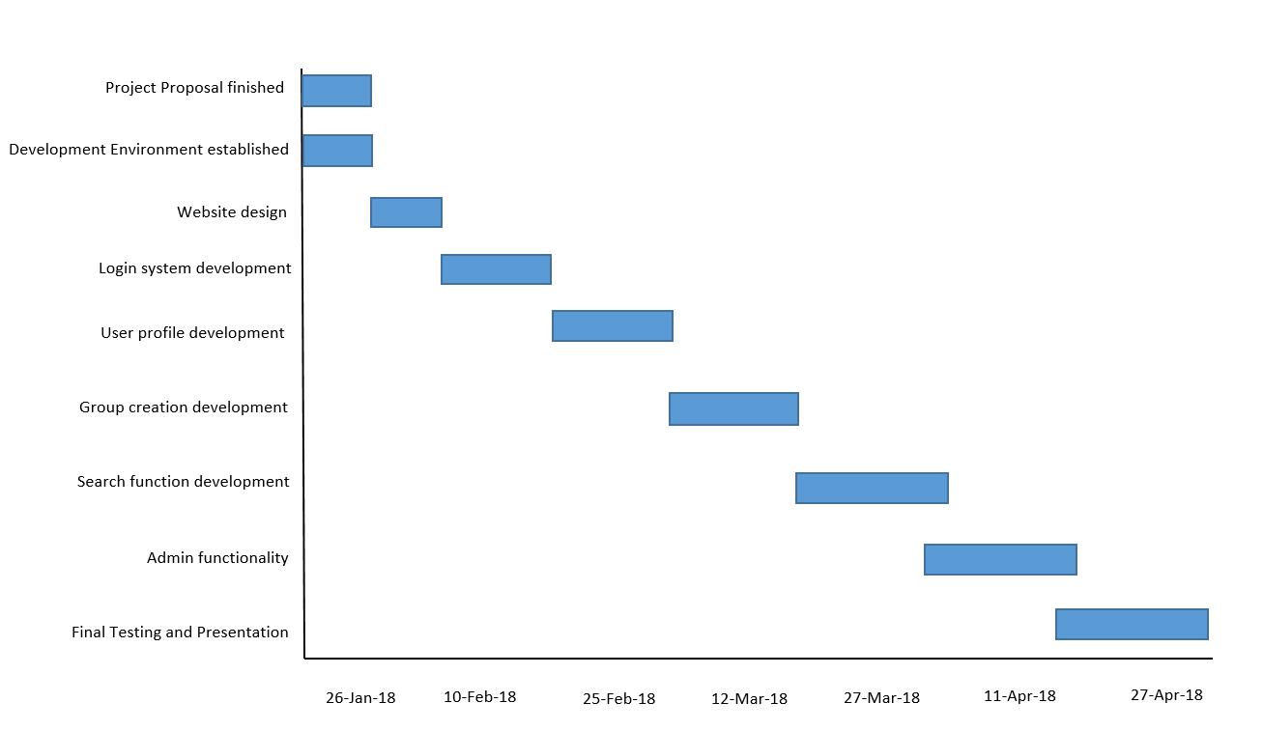

*Figure 2: A Gantt Chart of the team’s estimated project schedule*

***Site Map:***

*Figure 3. Site Map for Find Our RoomMate Questionnaire*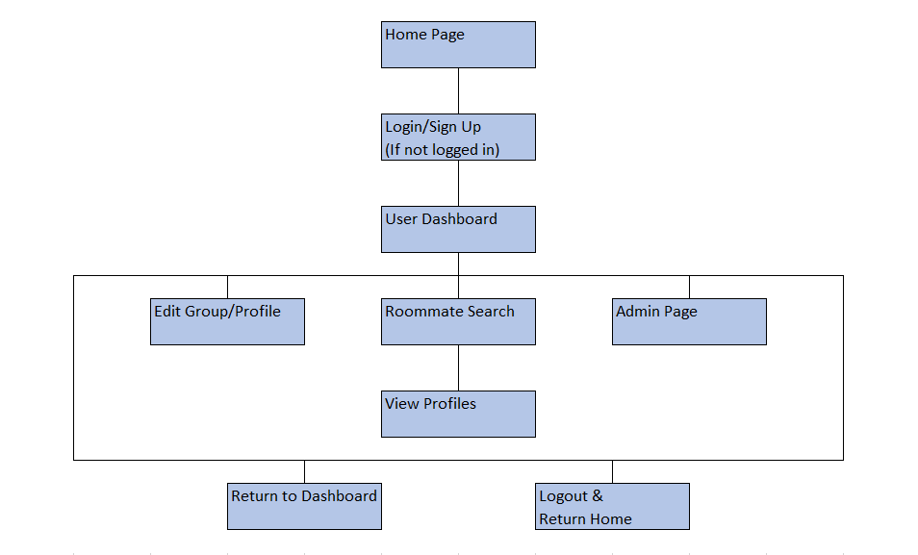

***Wireframes:***

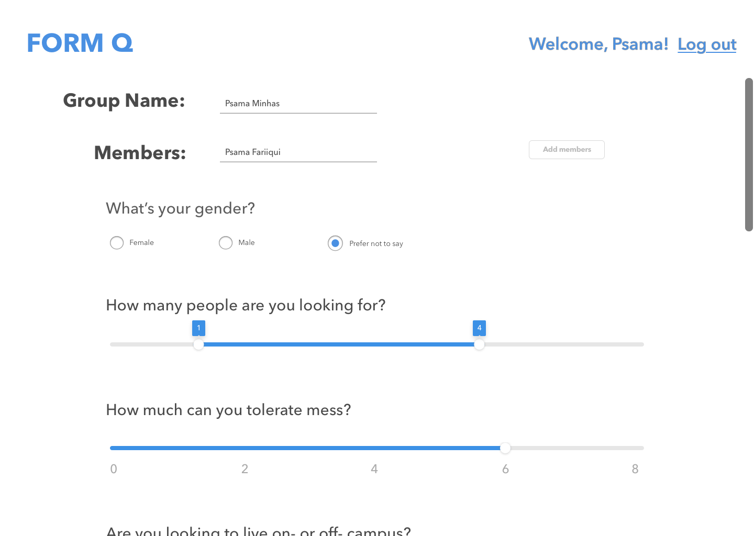

*Figure 4: A wireframe of the screen used to create groups from the user dashboard.*

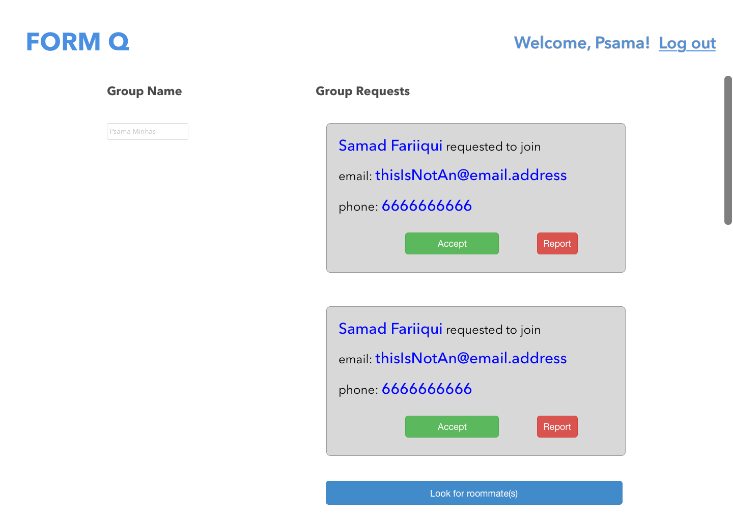

*Figure 5: A wireframe of the user’s dashboard.*